TICO USBACC – Integration test report
About this document
This document presents the details of the functional (integration) testing performed on the USBACC. It begins with a general introduction outlining the purpose of the tests, the test modules and methodologies employed, and the overall test setup used for the functional testing.
The following sections describe the tests conducted on the main PCB and the HVDC filter PCB at system level, explaining how the respective interfaces and functions were verified. The final sections present the consolidated test results, key observations, and overall conclusions from the testing activities.
Scope
The scope of this testing is functional testing. The report captures details of the tests executed with their objectives, setup, methods, criteria, condition, results and conclusions.

Intended audience
This document is intended for the hardware design team, including the hardware design architect and hardware engineers involved in circuit development, testing, and validation. It is also useful for stakeholders seeking detailed insights into the design process, performance analysis and any potential improvements for the circuit under test.

List of pending items
S. No | Description | Updation Plan
1 | HV DCDC test – with actual transformer from NJ, will be conducted again in Phase 4. | Phase 4
2 | Countermeasures to address failure due to overheating under 1.5 kW load conditions will be re-tested in Phase 4. | Phase 4
3 | As this is a third round of review with SCTM BE and TICO-San, there is no plan to change the following calculation basis in this phase of the project. All the voltage values from the data sheet are used as is without any rounding-off, the voltage measurement values using oscilloscope are rounded upto 3 digits and the current measurement values, power, wattage and efficiency calculations are rounded upto 2 digits. In case all the measurements and calculations are to be aligned to 2 digits, the same will be updated in the next phase of the project. | Phase 4

Reference documents
S. No | Description | Referred file name with version | Version | Date
1 | SRS (System Requirements Specifications) | ACC_SRS_Draft_04Jul25 .xlsx | 1.0 | 04-Jul-2025
2 | HDD (Hardware Design Document) | Hardware Design Document ACC_21_01_2026 | 1.0 | 21-Jan-2026
3 | Hardware/Software Interface Specification (HSIS) | USB_ACC_HSIS.xlsx | 1.0 | 12-Jan-2026
4 | WCCA Sheet | USBACC_WCCA_Analysis_23012026.xlsx | 1.2 | 23-Jan-2026
5 | Schematics | Schematic Main PCB  Schematic HVDC Filter PCB | 1.2 | 09-Jan-2026
6 | SDD (Software Design Document) | ACC_Ph3_SDD_25_02_2026 | 1.1 | 25-Feb-2026

Revision history
Version No. | Date | Change Description | Prepared By | Reviewed By | Approved By
0.1 | 29-Jan-2026 | Initial creation | Shikha | Sarup | Jaywant
0.2 | 30-Jan-2026 | Updated based on the comments from Mats-san | Shikha | Sarup | Jaywant
0.3 | 24-Feb-2026 | Updated USB PD Controller test in SPR and EPR modes | Shikha | Sarup | Jaywant
1.0 | 04-Mar-2026 | Updated based on TICO Konno san feedback | Shikha | Sarup | Jaywant
1.1 | 10-Mar-2026 | Updated based on TICO Konno san feedback | Shikha | Sarup | Jaywant
1.2 | 31-Mar-2026 | Updated based on TICO Konno san feedback | Shikha | Sarup | Jaywant

Table of Contents
1. General introduction 4
1.1 Purpose of the tests 4
1.2 Main PCB 5
1.2.1 Test modules and methods 5
1.3 HVDC Filter PCB 5
1.3.1 Test modules and methods 5
1.4 Test setup TICO USBACC functional testing 6
1.5 Circuits considered identical for integration test 6
2 Main PCB test 8
2.1 Buck controller test 8
2.1.1 Test criteria 8
2.1.2 Test setup 8
2.1.3 Test method 9
2.1.4 Test results 9
2.1.5 Conclusion 11
2.2 Buck-Boost controller test 12
2.2.1 Test criteria 12
2.2.2 Test setup 12
2.2.3 Test method 12
2.2.4 Test results 14
2.2.5 Conclusion 17
2.3 HV DCDC test 18
2.3.1 Test criteria 18
2.3.2 Test setup 18
2.3.3 Test method 19
2.3.4 Test results 19
2.3.5 Conclusion 22
2.4 Power Supply Voltage Regulator 23
2.4.1 Test criteria 23
2.4.2 Test setup 23
2.4.3 Test method 23
2.4.4 Test result 24
2.4.5 Conclusion 24
2.5 PD Controller test in SPR and EPR modes 25
2.5.1 Test criteria 25
2.5.2 Test setup 25
2.5.3 Test method 25
2.5.4 Test result 27
2.5.5 Conclusion 36
3 HVDC Filter PCB test 37
3.1 Test criteria 37
3.2 Test setup 37
3.3 Test method 37
3.4 Test results 39
3.5 Conclusion 39
4 Abbreviations list 40

General introduction

Purpose of the tests
Purpose of the test is to verify the defined functionalities of the main PCB and HVDC Filter PCB circuit, against specifications (SRS and the respective data sheets) and to identify any potential issues or areas for improvement.

Across the main PCB and HVDC Filter PCB, testing emphasizes output accuracy, response speed, noise performance, and stability under lab conditions.

Note: Lab conditions in this document mean that the PCB is tested in the laboratory at room temperature, without extra mechanical or environmental stress, PCB is out of case, and no cooling fan was used.

Equipment List:
Sr. No | Test Tool / Equipment | Model number/ Manufacturer | Exact Usage
1 | USB Power Delivery Tester | PM240 / Passmark Software | Measure USB V/I/P, PD negotiation, detect faults
2 | USB Electronic Load / PD Load | PM240 / Passmark Software | Draw controlled USB load (SPR / EPR / overload)
3 | Digital Multimeter (DMM) | Metrasafe-10 / Metravi Instruments Pvt. Ltd. | Measure ACC output voltage
4 | Digital Storage Oscilloscope (DSO) + Current Probe | MS05104 / RIGOL | Measure and show voltage and current waveforms
5 | Programmable HVDC Power Supply | VMKG4K / Volt Control Systems | Apply and sweep DC input
6 | CAN Analyzer | Waveshare | Send mode commands, monitor status & faults
7 | E² Studio IDE | Laptop with E² Studio software | Programming Renesas controller
Table 1 Equipment List
Main PCB:
This board has the microcontroller, digital isolator, Buck-Boost controller, PD controller, Buck controller, communication interface (CAN), temperature sensors, current sensors, HV DCDC- primary switching, IGBT, transformer, flyback circuit, and secondary rectifier diode.
HVDC Filter PCB:
This board has the HVDC Filter section and a B2B connector used on the primary side of the HV DCDC circuits.

Main PCB
Functional testing of the main PCB is conducted under lab conditions (product under development) to verify I/O and communication. Scope includes Buck controller, Buck-Boost controller, USB PD Controller and HV DCDC circuit on the main board.

Test modules and methods
The main PCB testing is carried out for the following interfaces and their respective functionality
- Buck controller test — Verify readings across full load conditions and constant output voltage with efficiency.
- Buck-Boost controller test — Verify readings across varying inputs with load calculated accordingly.
- HV DCDC test — Verify readings across the high voltage range, check offset, gain, and response to changing load at output.
- Power Supply Voltage Regulator — Verify the output stabilizes at 5V.
- USB PD Controller test in SPR and EPR modes— Verify the USB output port reading in SPR and EPR modes.

HVDC Filter PCB
Circuit functional test is conducted to verify proper functioning of HVDC Filter circuit.

Test modules and methods
The HVDC filter test is conducted to check output accuracy and stability.
- HVDC Filter test — Verify that the output voltage closely follows the input voltage with high efficiency under varying load conditions.

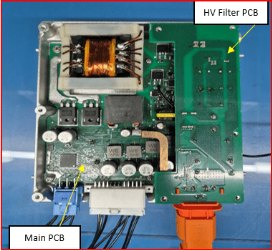
Test setup TICO USBACC functional testing

USB Load/PD Load
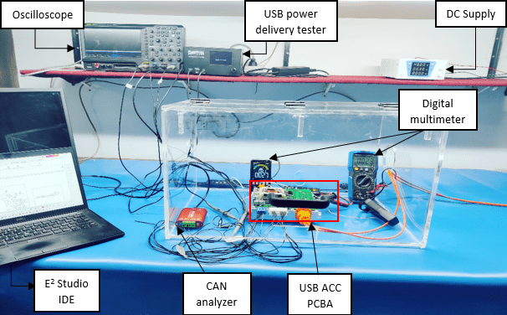

Figure 1 USBACC functional test setup with both PCBA

Circuits considered identical for integration test
Identical circuits that are implemented multiple times in the design, only one representative circuit is tested in this bring-up; the remaining circuits are considered equivalent. The following table (Table 2) lists the identical circuits in USBACC.
Group No. | Representative circuit tested | Circuits considered identical (not individually tested)
1 | USB Buck-Boost Controller | - USB Buck-Boost Controller 2  - USB Buck-Boost Controller 3  - USB Buck-Boost Controller 4
2 | USB PD Controller | - USB PD Controller 2
Table 2 Circuits considered identical

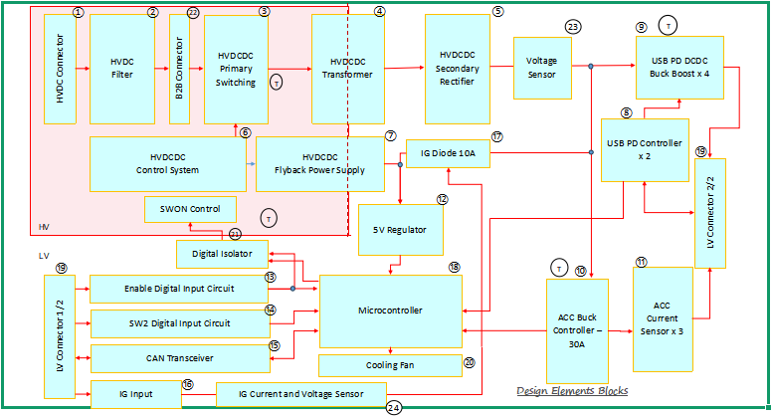
Figure 2 PCB level circuit block diagram

PCB | Circuit & components considered for test
Main PCB | 3,4,5,6,7,8,9,10,12,19
HVDC Filter PCB | 1,2,22
Table 3 PCB level list of circuit & components considered for test

Main PCB test
Test objective
The main PCB is verified in a structured, repeatable flow covering the Buck circuit, Buck-Boost circuit, USB PD Controller and HV DCDC. These measured results are reviewed against defined acceptance criteria to determine compliance under lab conditions.

Buck controller test

Test criteria
The Buck controller is tested by observing both input and output pulses on the oscilloscope. The objective of this test is to verify the constant output voltage by increasing the load 10 A, 20 A and 30 A.
Expected output Voltage (± 1.38 %) | Expected output current (≤ 42.43 A)
12.821 V – 13.179 V | 10.00 A
 | 20.00 A
 | 30.00 A
Table 4 Expected output for Buck controller test
Note: Based on WCCA, mention in (ACC_Buck) sheet the worst-case output tolerance error for the MPQ9934 ACC Buck controller is ± 1.38 %, under ideal test conditions for the 13 V output pass criteria range is 12.821 V – 13.179 V. The worst-case maximum output current is 42.43 A, as mentioned in WCCA (ACC_Buck_Inductor) sheet.

Test setup
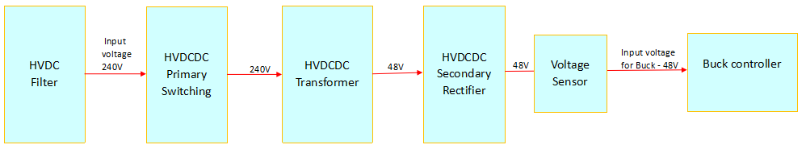

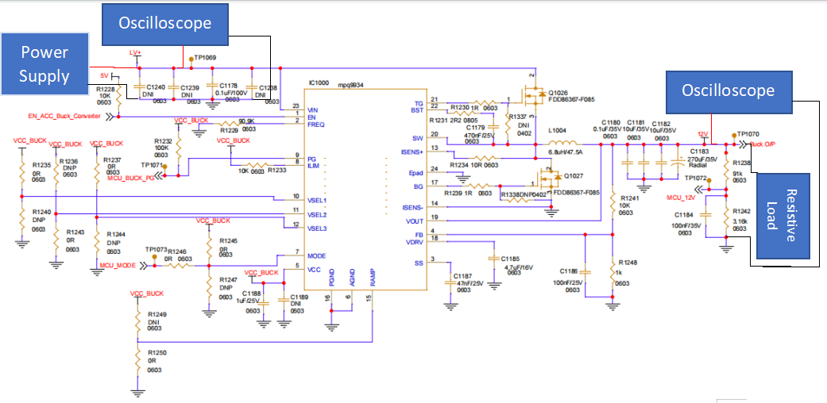
Figure 3 Buck controller circuit with block diagram showing input voltage for Buck controller
The Buck controller circuit enables EN_ACC_Buck_Converter signal (IC MPQ9934) with LV+ input voltage. The operation of the two FET switches across the full load generates the buck output.

Test method
Step 1: Power the board
- Apply LV+ input using a programmable DC power supply to TP1069 (LV+).
- Connect the DC supply return to PGND/GND and set LV+ to the required nominal input voltage per specification.
- Enable current limit high enough to avoid supply current limiting during loading.
- Turn ON LV+ and confirm the board powers up normally.
Step 2: Enable Buck
- For this test, use an external jumper to connect the 5 V regulator output to the buck enable (EN) pin.
Step 3: Connect oscilloscope
- CH1 (Yellow) → connect to TP1069 (LV+) to monitor input voltage waveform.
- CH2 (Light Blue) → connect to input current measurement using a current probe on the supply lead feeding TP1069.
- CH3 (Pink) → connect to TP1070 (Buck O/P) to monitor output voltage waveform.
- CH4 (Blue) → connect to output current measurement using a current probe on the lead from TP1070 → resistive load.
Step 4: Apply resistive load & capture results
Case | Test | Target Current | Load
A | 120 W | 10.00 A | ~1.30 Ω
B | 240 W | 20.00 A | ~0.65 Ω
C | 360 W | 30.00 A | ~0.43 Ω
Table 5 Buck result list table
- Connect resistive load across TP1070 (Buck O/P) and PGND/GND, start with high resistance (low current).
- Set resistive load to achieve each test current and record readings + waveform.
Case A: 120 W
- Adjust load to obtain ~10.00 A, capture waveform and record results.
Case B: 240 W
- Adjust load to obtain ~20.00 A, capture waveform and record results.
Case C: 360 W
- Adjust load to obtain ~30.00 A, capture waveform and record results.
Step 5: Shutdown
- Reduce load to minimum / disconnect load safely.
- Turn OFF LV+ supply.

Test results
Case A: 120 W Output Result
Note:
Blue → output current signal
Yellow → LV+ input voltage signal
Pink → Buck O/P (buck output signal)
Light Blue → input current signal
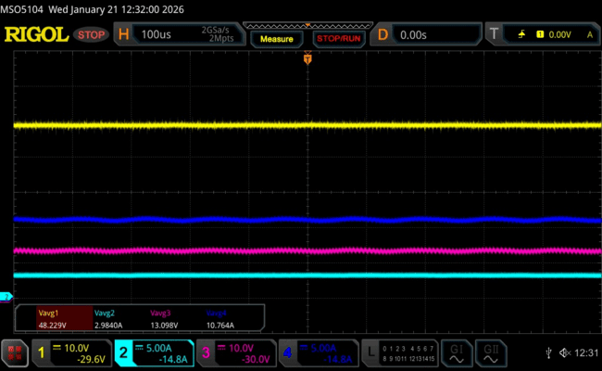
Figure 4 Buck Input and Output waveform for 120 W

Parameter | Expected | Measured | Pass Criteria | Judgement
Output Voltage | 13.000 V | 13.098 V | 12.821 V – 13.179 V | PASS
Output Current | 10.00 A | 10.76 A | ≤ 42.43 A | PASS
Table 6 Buck output for 120 W test result verification table
*±1.38 % of 13.000 V as calculated from WCCA
Case B: 240 W Output Result
Note:
Blue → output current signal
Yellow → LV+ input voltage signal
Pink → Buck O/P (buck output signal)
Light Blue → input current signal
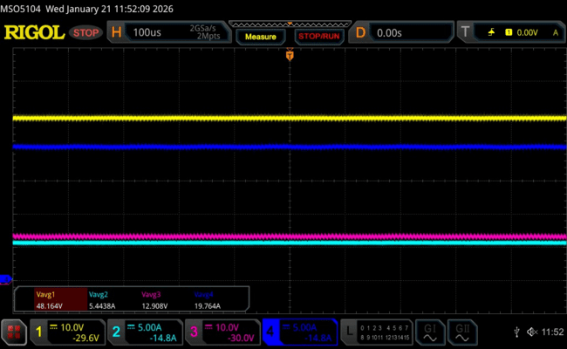
Figure 5 Buck Input and Output waveform for 240 W
Parameter | Expected | Measured | Pass Criteria | Judgement
Output Voltage | 13.000 V | 12.908 V | 12.821 V – 13.179 V | PASS
Output Current | 20.00 A | 19.76 A | ≤42.43 A | PASS
Table 7 Buck output for 240 W test result verification table
*±1.38 % of 13.000 V as calculated from WCCA
Case C: 360 W Output Result
Note:
Blue → output current signal
Yellow → LV+ input voltage signal
Pink → Buck O/P (buck output signal)
Light Blue → input current signal
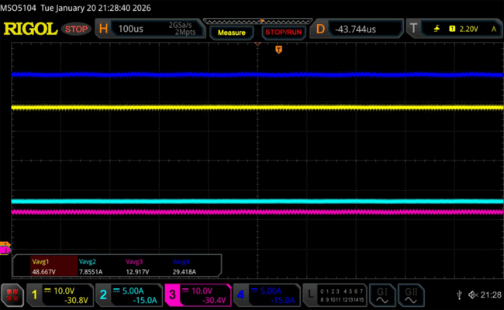
Figure 6 Buck Input and Output waveform for 360 W
Parameter | Expected | Measured | Pass Criteria | Judgement
Output Voltage | 13.000 V | 12.917 V | 12.821 V – 13.179 V | PASS
Output Current | 30.00 A | 29.42 A | ≤42.43 A | PASS
Table 8 Buck output for 360 W test result verification table
*±1.38 % of 13.000 V as calculated from WCCA

Conclusion
Oscilloscope measurements verify that when the buck converter was tested at 120 W, 240 W, and 360 W output power levels. In all test conditions, both output voltage and output current remained within the specified tolerance limits. This confirms that the converter provides regulation across the full load range.

Buck-Boost controller test

Test criteria
Buck-Boost controller is tested under buck and boost modes by varying LV+ voltage. The objective of this test is to verify the functional performance, voltage regulation accuracy, and current using both input and output pulse on the oscilloscope.
Input Voltage | Expected output current | Expected calculated voltage (±2%)
58.000 V | ≤9.60 A | 47.040 V – 48.960 V
 |  | 4.900 V – 5.100 V
25.000 V | ≤9.60 A | 47.040 V – 48.960 V
 |  | 4.900 V – 5.100 V
10.000 V | ≤9.60 A | 47.040 V – 48.960 V
 |  | 4.900 V – 5.100 V
Table 9 Expected output for Buck-Boost test
Note: Based on WCCA, mention in (USB_Buck_Boost) sheet the maximum worst-case SiC FET measurement error for the MPQ4208 Buck-Boost controller is ±2 %, under ideal test conditions for the 48 V output pass criteria range is 47.040 V – 48.960 V and 5 V output pass criteria range is 4.900 V – 5.100 V. The maximum worst-case analysis measurement for current is ≤9.60 A mention in (USB_Inductor) sheet.

Test setup
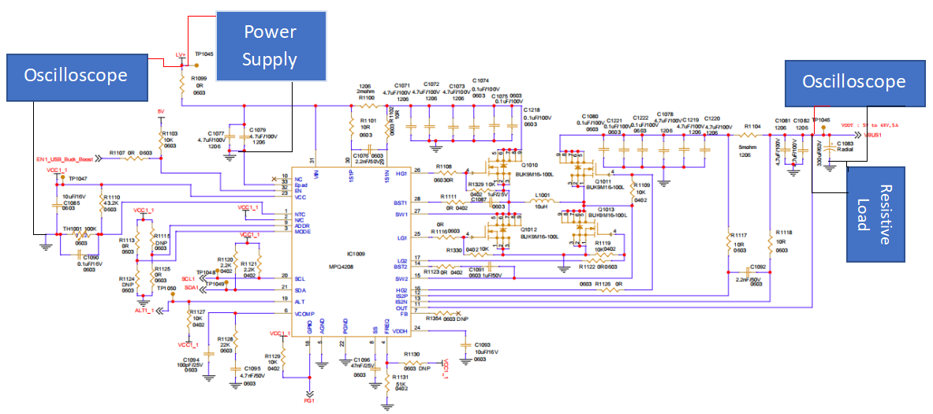
Figure 7 Buck-Boost controller test circuit
The Buck-Boost controller circuit verification uses the MPQ4208 (IC1009) with an LV+ power supply applied. The MCU asserts EN_USB_Buck_Boost powered with 5 V power supply regulator enables IC MPQ4208. The MPQ4208 integrates a four FET switch Buck-Boost controller. The Buck-Boost controller works with fixed 400 kHz frequency in buck, boost, and buck-boost modes.

Test method
Step 1: Power the board
- Apply LV+ input using a programmable DC power supply to TP1045 (LV+).
- Connect the DC supply return to PGND/GND and set LV+ to the required input voltage per test case (58.000 V / 25.000 V / 10.000 V).
- Enable current limit high enough to avoid supply current limiting during loading.
- Turn ON LV+ and confirm the board powers up normally.
Step 2: Enable Buck-Boost
- For this test, assert EN_USB_Buck_Boost HIGH using the 5 V regulator output (external jumper / 5 V source).
Step 3: Connect oscilloscope
- CH1 (Yellow) → connect to TP1045 (LV+) to monitor input voltage waveform.
- CH2 (Light Blue) → connect to input current measurement using a current probe on the supply lead feeding TP1045.
- CH3 (Pink) → connect to TP1046 (VBUS1 / Output) to monitor output voltage waveform.
- CH4 (Blue) → connect to output current measurement using a current probe on the lead from TP1046 → load.
Step 4: Apply load & capture results
- Connect the load across TP1046 (VBUS1 / Output) and PGND/GND, start with minimum load (safe condition).
- Adjust the load to achieve the required output voltage/current for each test case, then capture waveforms and record results.
Case | Test Condition | Target Output | Target Current | Load
A | Max HV input (58.000 V) → 48.000 V output | 48.000 V | 5.00 A | ~9.60 Ω
B | Min HV input (25.000 V) → 48.000 V output | 48.000 V | 5.00 A | ~9.60 Ω
C | Min IG input (10.000 V) → 48.000 V output | 48.000 V | 2.00 A | ~24.00 Ω
D | Max HV input (58.000 V) → 5.000 V output | 5.000 V | 5.00 A | ~1.00 Ω
E | Min HV input (25.000 V) → 5.000 V output | 5.000 V | 5.00 A | ~1.00 Ω
F | Min IG input (10.000 V) → 5.000 V output | 5.000 V | 5.00 A | ~1.00 Ω
Table 10 Buck-Boost result list
Case A: Max HV input (58.000 V) → 48.000 V / 5.00 A
- Set LV+ = 58.000 V at TP1045, adjust load to 48.000 V / ~5.00 A, capture waveform and record results.
Case B: Min HV input (25.000 V) → 48.000 V / 5.00 A
- Set LV+ = 25.000 V at TP1045, adjust load to 48.000 V / ~5.00 A, capture waveform and record results.
Case C: Min IG input (10.000 V) → 48.000 V / 2.00 A
- Set LV+ = 10.000 V at TP1045, adjust load to 48.000 V / ~2.00 A, capture waveform and record results.
Case D: Max HV input (58.000 V) → 5.000 V / 5.00 A
- Set LV+ = 58.000 V at TP1045, adjust load to 5.000 V / ~5.00 A, capture waveform and record results.
Case E: Min HV input (25.000 V) → 5.000 V / 5.00 A
- Set LV+ = 25.000 V at TP1045, adjust load to 5.000 V / ~5.00 A, capture waveform and record results.
Case F: Min IG input (10.000 V) → 5.000 V / 5.00 A
- Set LV+ = 10.000 V at TP1045, adjust load to 5.000 V / ~5.00 A, capture waveform and record results.
Step 5: Shutdown
- Reduce load to minimum / disconnect load safely.
- Turn OFF LV+ supply.

Test results
Case A: Max HV input (58.000 V) and 48.000 V/5.00 A output
Note:
Light Blue → input current signal
Yellow → LV+ input voltage signal
Pink → output voltage signal
Blue → output current signal
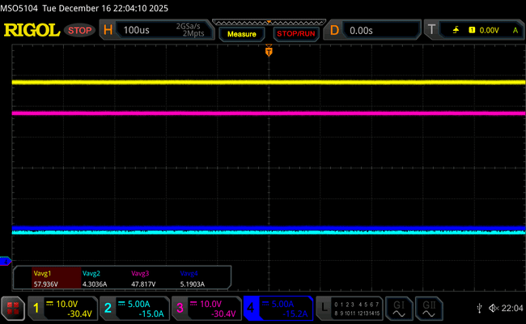
Figure 8 Buck mode Input and Output waveform
Parameter | Expected | Measured | Pass Criteria | Judgement
Output Voltage | 48.000 V | 47.817 V | 47.040 V – 48.960 V | PASS
Output Current | 5.00 A | 5.19 A | ≤9.60 A | PASS
Table 11 Buck mode output voltage test result verification table
*±2 % of 48.000 V as calculated from WCCA
Case B: Min HV input (25.000 V) and 48.000 V/5.00 A output
Note:
Light Blue → input current signal
Yellow → LV+ input voltage signal
Pink → output voltage signal
Blue → output current signal
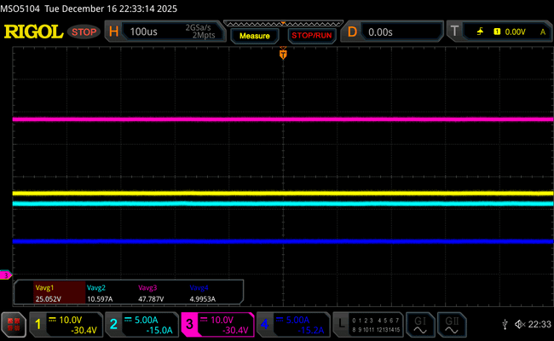
Figure 9 Boost mode Input and Output waveform

Parameter | Expected | Measured | Pass Criteria | Judgement
Output Voltage | 48.000 V | 47.787 V | 47.040 V – 48.960 V | PASS
Output Current | 5.00 A | 5.00 A | ≤9.60 A | PASS
Table 12 Boost mode output voltage test result verification
*±2 % of 48.000 V as calculated from WCCA
Case C: Min IG input (10.000 V) and 48.000 V/2.00 A output
Note:
Light Blue → input current signal
Yellow → LV+ input voltage signal
Pink → output voltage signal
Blue → output current signal
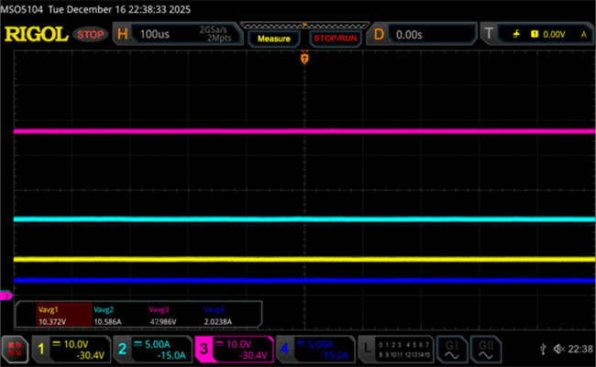
Figure 10 Boost mode Input and Output waveform
Parameter | Expected | Measured | Pass Criteria | Judgement
Output Voltage | 48.000 V | 47.986 V | 47.040 V – 48.960 V | PASS
Output Current | 2.00 A | 2.02 A | ≤9.60 A | PASS
Table 13 Boost mode output voltage test result verification table
*±2 % of 48.000 V as calculated from WCCA

Case D: Max HV input (58.000 V) and 5.000 V/5.00 A output
Note:
Light Blue → input current signal
Yellow → LV+ input voltage signal
Pink → output voltage signal
Blue → output current signal
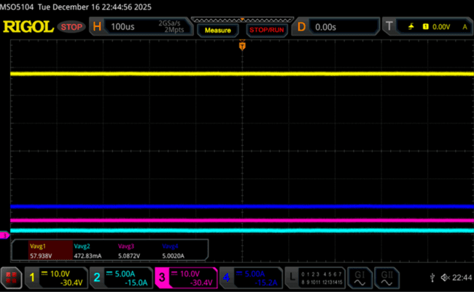
Figure 11 Buck mode Input and Output waveform
Parameter | Expected | Measured | Pass Criteria | Judgement
Output Voltage | 5.000 V | 5.087 V | 4.900 V – 5.100 V | PASS
Output Current | 5.00 A | 5.00 A | ≤9.60 A | PASS
Table 14 Buck mode output voltage test result verification table
*±2 % of 5.000 V as calculated from WCCA
Case E: Min HV input (25.000 V) and 5.000 V/5.00 A output
Note:
Light Blue → input current signal
Yellow → LV+ input voltage signal
Pink → output voltage signal
Blue → output current signal
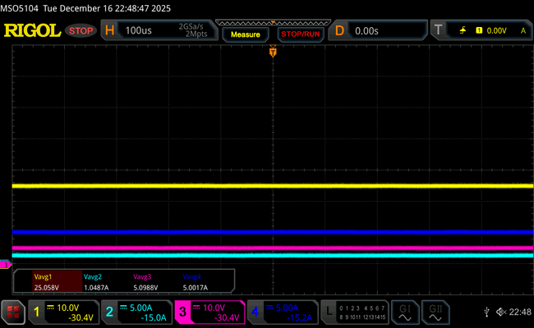
Figure 12 Buck mode Input and Output waveform
Parameter | Expected | Measured | Pass Criteria | Judgement
Output Voltage | 5.000 V | 5.099 V | 4.900 V – 5.100 V | PASS
Output Current | 5.00 A | 5.00 A | ≤9.60 A | PASS
Table 15 Buck mode output voltage test result verification table
*±2 % of 5.000 V as calculated from WCCA
Case F: Min IG input (10.000 V) and 5.000 V/5.00 A output
Note:
Light Blue → input current signal
Yellow → LV+ input voltage signal
Pink → output voltage signal
Blue → output current signal
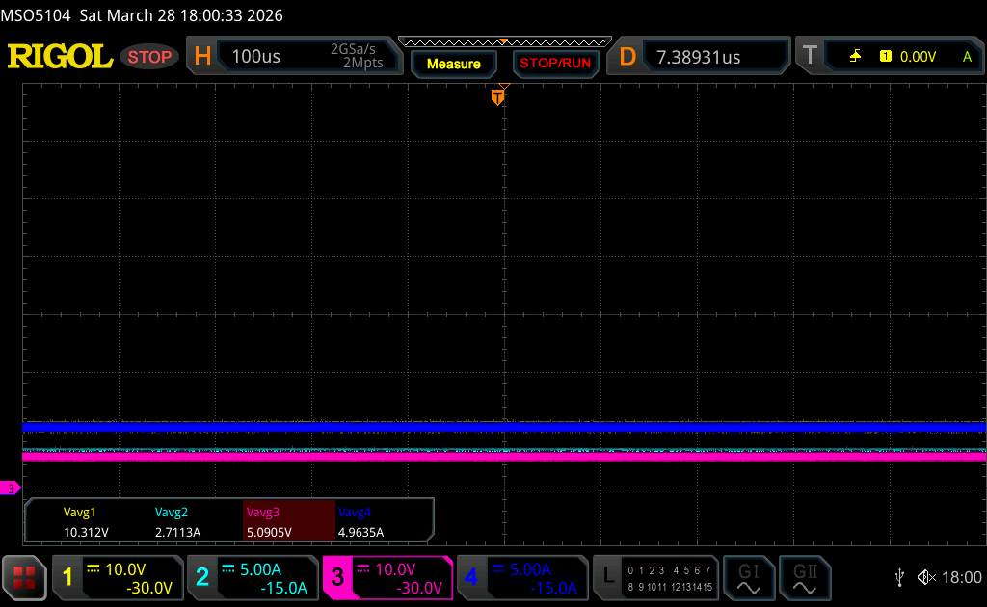
Figure 13 Buck mode Input and Output waveform
Parameter | Expected | Measured | Pass Criteria | Judgement
Output Voltage | 5.000 V | 5.091 V | 4.900 V – 5.100 V | PASS
Output Current | 5.00 A | 4.96 A | ≤9.60 A | PASS
Table 16 Buck mode output voltage test result verification
*±2 % of 5.000 V as calculated from WCCA

Conclusion
The buck-boost converter was tested under six operating conditions across wide input and output ranges. All six test cases met the ±2 % voltage tolerance. The buck-boost converter maintained regulated and stable output across minimum and maximum input conditions, including high-output (48.000 V) and low-output (5.000 V) operating points. Hence, all the test cases have passed the test criteria.

HV DCDC test

Test criteria
The HV DCDC is tested by using input voltage given to HVDC filter circuit, IGBTs, followed by center tapped transformer (hand wound) and diode. Its turns ratio is 9:2, with a switching frequency of 80 kHz and an output range of 27.400 V to 51.800 V. The HV DCDC is tested at 1.50 kW, 1.20 kW, 0.90 kW, 0.60 kW and 0.30 kW load.

Input Power | Expected minimum Output power for 92.11% efficiency
1.50 kW (100%) | 1.38 kW
1.20 kW (80%) | 1.11 kW
0.90 kW (60%) | 0.83 kW
0.60 kW (40%) | 0.55 kW
0.30 kW (20%) | 0.28 kW
Table 17 Expected output for HV DCDC test
Note:
- Based on HV DCDC MATLAB simulation for Low variant 9:2 transformer, efficiency is 87.72% for 130 V and 92.11% for 240 V for 1.5 kW output. So, pass criteria for all test is considered 92.11% efficiency.
- The rationale for the Input Power settings - These increments were chosen to evaluate the performance across the full load range from maximum load to minimum load conditions.

Test setup
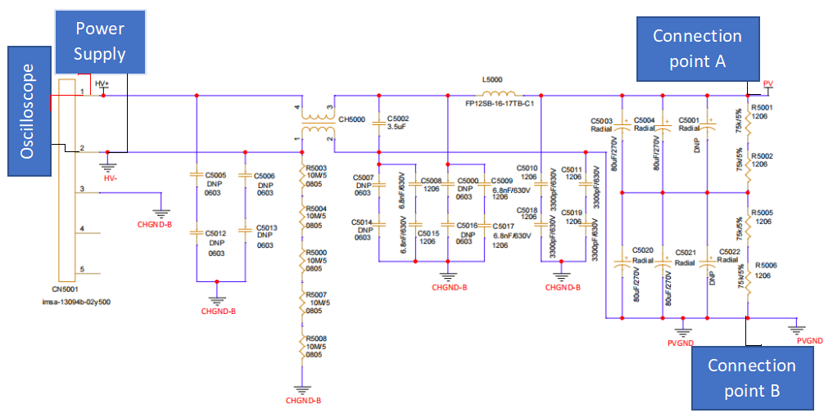
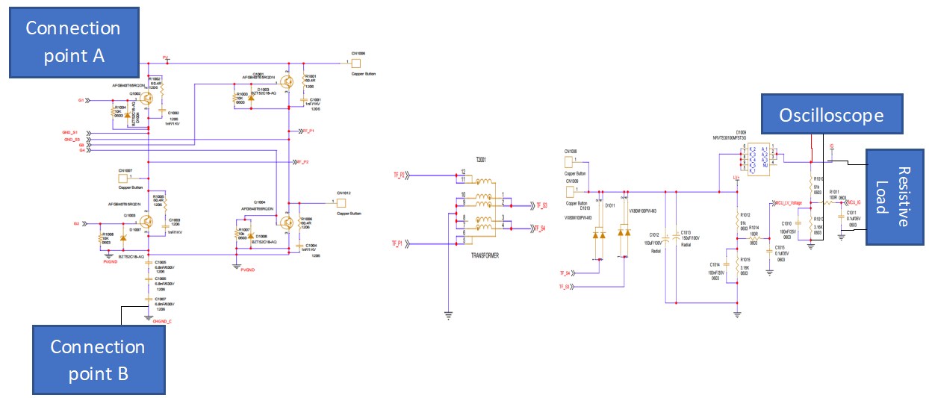
Figure 14 HV DCDC test circuit

Test method
The test uses the input filter circuit and operates in the low operating range (9:2). All the above tests are taken by considering the nominal HV DCDC output voltage (48 V).
Step 1: Power
- Connect input supply to HV+ pin 1(CN5001).
- Tie supply HV GND to board HV- signal (Power stage remains disconnected).
Step 2: Connect B2B connector
- Connect PV and PVGND with main PCB through B2B connector (CN5000).
Step 3: Apply Load
- Load setup at R1012 output LV+ signal with one end attached GND (Power stage remains disconnected).
Case 1: 1.5 kW Output Result
Set HV+ = 240 V at the HV DCDC input, adjust the load to 48 V / ~31.25 A, capture the waveform and measure the output power.
Case 2: 1.2 kW Output Result
Set HV+ = 240 V at the HV DCDC input, adjust the load to 48 V / ~25.00 A, capture the waveform and measure the output power.
Case 3: 0.90 kW Output Result
Set HV+ = 240 V at the HV DCDC input, adjust the load to 48 V / ~18.75 A, capture the waveform and measure the output power.
Case 4: 0.60 kW Output Result
Set HV+ = 240 V at the HV DCDC input, adjust the load to 48 V / ~12.50 A, capture the waveform and measure the output power.
Case 5: 0.30 kW Output Result
Set HV+ = 240 V at the HV DCDC input, adjust the load to 48 V / ~6.25 A, capture the waveform and measure the output power.
Step 4: Connect oscilloscope
- CH1 (Yellow) → connect to CN5001(pin 1) (HV+) to monitor input voltage waveform.
- CH2 (Light Blue) → connect to input current measurement using a current probe on the supply lead feeding CN5001(pin1).
- CH3 (Pink) → connect to LV+ (R1012) to monitor output voltage waveform.
- CH4 (Blue) → connect to output current measurement using a current probe on the lead from R1012 → load.
Step 5: Verification
- Monitor parameters like output voltage and current, input voltage and current. Observe the circuit output behaviour.
Step 6: Shutdown
- Reduce load to minimum / disconnect load safely.
- Turn OFF HV+ supply.

Test results
Note: The following HV DCDC test was conducted with a hand-wound transformer; a retest will be done with custom transformer when it will be available and test result verification table will be updated.

* The DSO used for measurement has a fixed 5-digit resolution for displayed values. The last digit written as 0 in the table only to maintain a consistent three-decimal format and it does not represent an additional measurement; it only indicates that no further precision is available beyond the instrument resolution.
1) 1.5 kW Output Result
Note:
Light Blue → HVDC filter input current signal
Yellow → HVDC filter input voltage signal
Pink → output voltage signal
Blue → output current signal
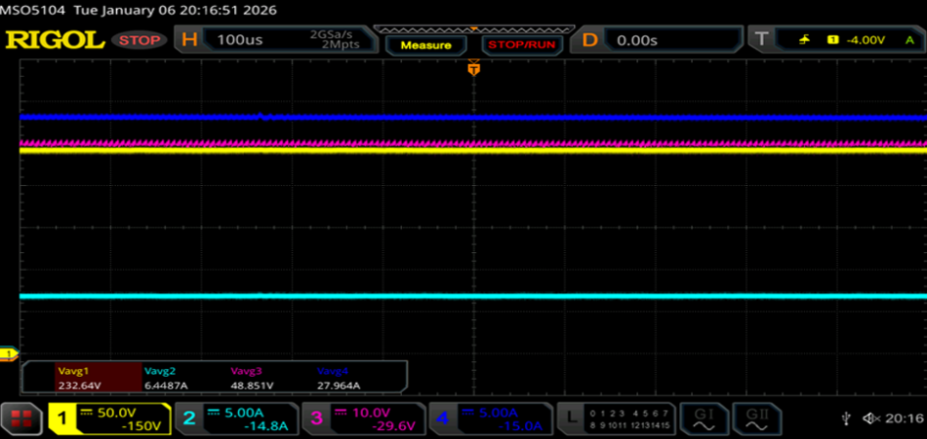
Figure 15 HV DCDC Input and Output waveform
Parameter | Input Measured | Output Measured
Voltage | 232.64V | 48.851 V
Current | 6.45 A | 27.96 A

Parameter | Expected | Pass Criteria | Measured |  | Judgement
Output Power | 1.50 kW | ≥92.11 % | 91.33 % | 1.37 kW | Fail *
Table 18 HV DCDC output power test result verification table
* Since the transformer in use is not the standardized transformer so this test will be re-performed post getting the required transformer and it is expected to pass the results when proper transformer is used.
2) 1.2 kW Output Result
Note:
Light Blue → HVDC filter input current signal
Yellow → HVDC filter input voltage signal
Pink → output voltage signal
Blue → output current signal
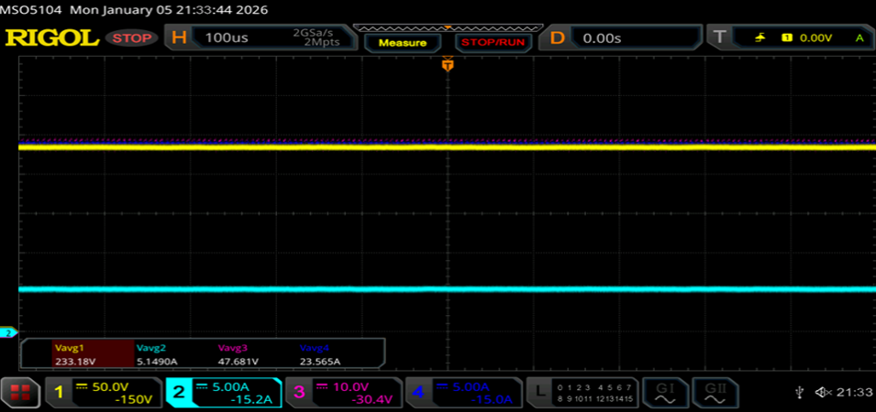
Figure 16 HV DCDC Input and Output waveform
Parameter | Input Measured | Output Measured
Voltage | 233.18 V | 47.681 V
Current | 5.15 A | 23.57 A

Parameter | Expected | Pass Criteria | Measured |  | Judgement
Output Power | 1.20 kW | ≥92.11 % | 93.33 % | 1.12 kW | Pass
Table 19 HV DCDC output power test result verification table

3) 0.90 kW Output Result
Note:
Light Blue → HVDC filter input current signal
Yellow → HVDC filter input voltage signal
Pink → output voltage signal
Blue → output current signal
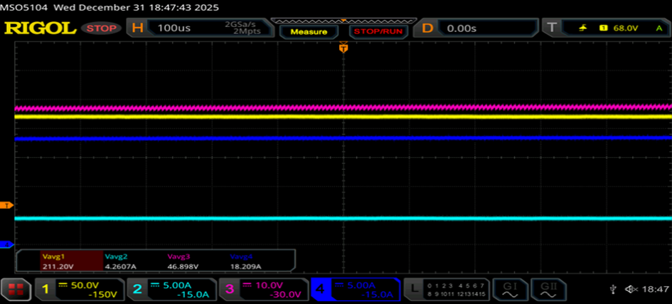
Figure 17 HV DCDC Input and Output waveform
Parameter | Input Measured | Output Measured
Voltage | 211.20 V | 46.898 V
Current | 4.26 A | 18.21 A

Parameter | Expected | Pass Criteria | Measured |  | Judgement
Output Power | 0.90 kW | ≥92.11 % | 94.44 % | 0.85 kW | Pass
Table 20 HV DCDC output power test result verification table
4) 0.60 kW Output Result
Note:
Light Blue → HVDC filter input current signal
Yellow → HVDC filter input voltage signal
Pink → output voltage signal
Blue → output current signal
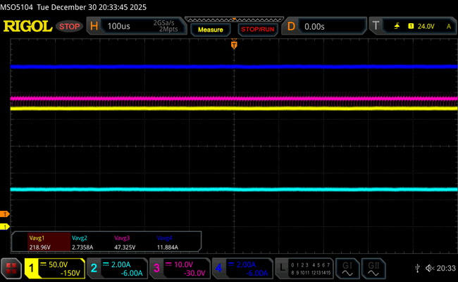
Figure 18 HV DCDC Input and Output waveform
Parameter | Input Measured | Output Measured
Voltage | 218.96 V | 47.325 V
Current | 2.74 A | 11.88 A

Parameter | Expected | Pass Criteria | Measured |  | Judgement
Output Power | 0.60 kW | ≥92.11 % | 93.33 % | 0.56 kW | Pass
Table 21 HV DCDC output power test result verification table

5) 0.30 kW Output Result
Note:
Light Blue → HVDC filter input current signal
Yellow → HVDC filter input voltage signal
Pink → output voltage signal
Blue → output current signal

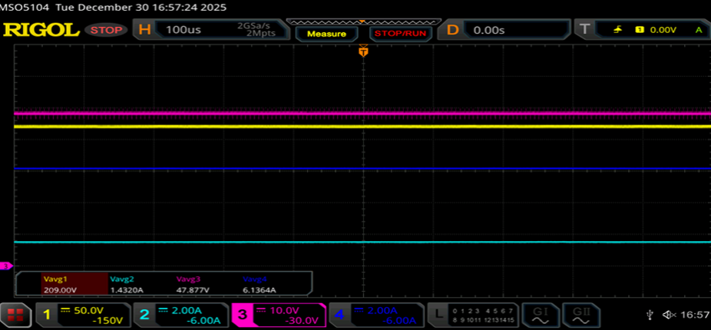
Figure 19 HV DCDC Input and Output waveform
Parameter | Input Measured | Output Measured
Voltage | 209.00 V | 47.877 V
Current | 1.43 A | 6.14 A

Parameter | Expected | Pass Criteria | Measured |  | Judgement
Output Power | 0.30 kW | ≥92.11 % | 96.67 % | 0.29 kW | Pass
Table 22 HV DCDC output power test result verification table

Conclusion
The HV DCDC converter operated normally for all tested load conditions at 0.30 kW, 0.60 kW, 0.90 kW, 1.2 kW and 1.5 kW. The output voltage results are within the low operation range (27.400 V - 51.800 V). The circuit functioned smoothly but overheating was observed at 1.5 kW load. Due to the hand-wound transformer and system overheating test 1) 1.5 kW does not meet the Pass criteria.

Power Supply Voltage Regulator

Test criteria
5 V Power supply voltage regulator is tested by powering it from a 12 V input and measuring the output on the oscilloscope. The output should regulate close to 5 V within the allowed tolerance.

Input Voltage (V) | Criteria (Expected)
12 V | 5.000 V ±2 % (4.900 V–5.100 V)
Table 23 Expected output for Power Supply Voltage Regulator test
Note: Based on WCCA, mention in (5 V Regulator) sheet the maximum worst-case measurement error for the NCV4275CDT50RKG 5 V linear regulator (LDO) is ±2%, under ideal test conditions for the 5 V output pass criteria range is 4.900 V–5.100 V.

Test setup
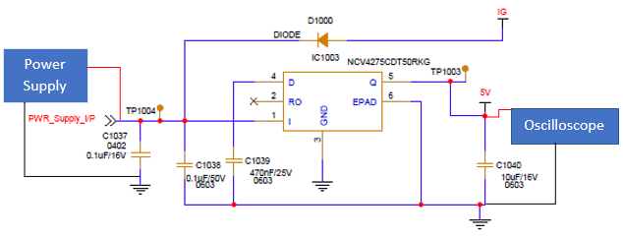
Figure 20 NCV4275CDT50RKG 5V linear regulator (LDO)

Test method
This test is conducted to verify that the NCV4275CDT50RKG 5 V linear regulator (LDO) provides a stable and accurate 5 V output from a 12 V input supply.
The input is powered with 12 V through the PWR_Supply_I/P net, and measurements are taken at the output (5 V).
Key aspects evaluated include:
- Correct output voltage (close to 5 V).
Step 1: Connect input power
- Connect the 12 V to TP1004 (PWR_Supply_I/P).
- Connect the GND of the DC power supply to the circuit GND (C1037).
This power the VIN pin of the NCV4275CDT50RKG (Pin 1).
Step 2: Connect oscilloscope
- Connect the probe ground to the system GND (C1040).
- CH1 (Yellow) → connect to TP1003 (5 V) to monitor output voltage waveform.
Step 3: Power ON and observe
- Turn ON the 12 V input supply.
- Monitor the output at 5 V on the oscilloscope.
- Verify that the output stabilizes at 5 V.

Test result
Note:
Yellow→ 5 V output voltage
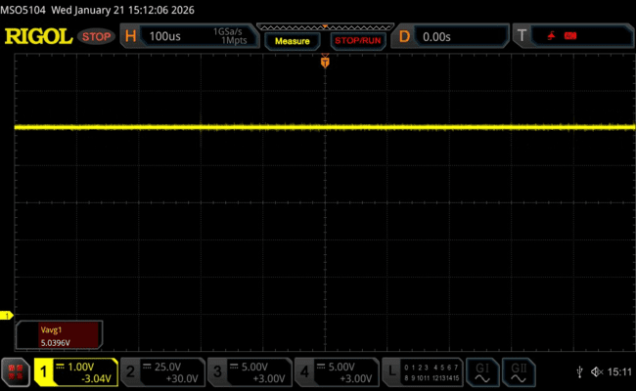Figure 21 NCV4275CDT50RKG 5 V linear regulator (LDO) test result
Parameter | Measured Value | Criteria (Expected) | Judgement
5 V Output Voltage | 5.040 V | 5.000 V ±2 % (4.900 V–5.100 V) | PASS
Table 24 NCV4275CDT50RKG 5 V linear regulator (LDO) test result verification table

Conclusion
The NCV4275CDT50RKG 5 V linear regulator (LDO) was tested with a 12 V input to verify output voltage accuracy and stability. The measured output voltage of 5.040 V lies within the specified ±2 % tolerance range of 4.900 V to 5.100 V. The oscilloscope waveform showed a stable DC output.

PD Controller test in SPR and EPR modes

Test criteria
This test verifies that in Normal Mode, the USBACC USB port supports SPR operation from 5 V to 20 V and EPR operation from 28V to 48V. The USB port shall successfully negotiate the correct PD contract type (SPR or EPR) and provide stable output at the selected voltage levels under load without output drop, renegotiation, shutdown, or fault indication.

Test setup
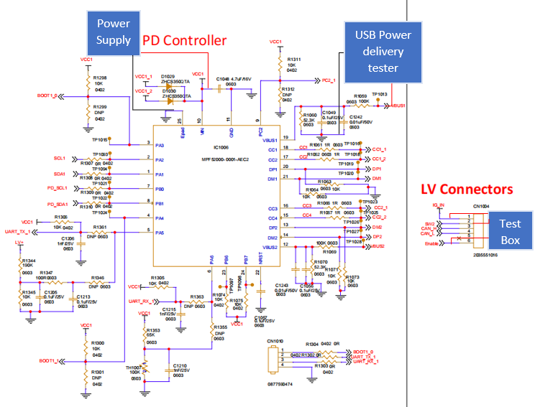
Figure 22 USB PD Controller test circuit

Test method
Step 1: USBACC Setup
- Place the fully assembled USBACC on the test bench.
- Ensure all test instruments are powered OFF before making connections.
Step 2: Power and Control Connections
- Connect the programmable HVDC power supply to the HV Connector and keep it set to 0 V (OFF) initially.
- Connect the Test Box IG LV DC power supply to LV Connector 1 (IG pin) and set IG = 0 V.
- Connect the Test Box digital output to the ENABLE pin on LV Connector 1 and set ENABLE = OFF.
- Connect the Test Box digital output to the SW2 (Restart) pin on LV Connector 1 and set SW2 = OFF.
- Connect the CAN Analyzer to LV Connector 1 and confirm CAN communication.

Step 3: USB Measurement Setup
- Connect the USB port under test on LV Connector 2 to a USB Power Delivery Tester capable of SPR and EPR profiles.
- Prepare logging to record PD contract type, negotiated voltage, output current, output power, and any fault indication.
- Ensure voltage and current measurement tools are available.
Step 4: Initial Condition Verification
- Confirm:
  - HVDC = 0V
  - IG = 0V
  - ENABLE = OFF
  - SW2 = OFF
Step 5: Power-Up and Normal Mode Selection
- Turn ON the IG supply and set IG = 12V.
- Set ENABLE = ON.
- Turn ON the HVDC supply and set HVDC = 200VDC.
- Using the CAN Analyzer, send the Normal Mode command.
- Confirm Normal Mode status.
A) SPR Mode Verification (5V to 20V)
Step 6: Establish PD Communication
- Connect the USB PD Tester to the USB port and confirm PD communication is established.
Step 7: SPR Voltage Level Verification
- Using the USB PD Tester, request the following SPR voltage levels one at a time:
  - 5V
  - 9V
  - 15V
  - 20V
- At each voltage level:
  - Apply the appropriate load.
  - Record:
    - Negotiated voltage
    - Output current
    - Output power
    - PD contract type = SPR
    - Output stability (no drop or renegotiation)
B) EPR Mode Verification (20V to 48V)
Step 8: EPR Voltage Level Verification
- Using the USB PD Tester, request the following EPR voltage levels one at a time:
  - 28V
  - 36V
  - 48V
- At each voltage level:
  - Apply the appropriate load.
  - Record:
    - Negotiated voltage
    - Output current
    - Output power
    - PD contract type = EPR
    - Output stability (no drop or renegotiation)
Step 9: Monitoring and Observation
- During each SPR and EPR test step, monitor and record:
  - Output voltage and current stability
  - PD contract status
  - Any output interruption, reset, or fault indication
Step 10: Power-Down Sequence
- Reduce USB load to 0W.
- Reduce HVDC input to 0V and turn OFF the HV supply.
- Set ENABLE = OFF.
- Confirm SW2 remains OFF.
- Set IG = 0V and turn OFF the IG supply.

Test result
1. Normal Mode Confirmation
Title: Normal Mode Activation Status
Evidence Type: CAN Analyzer Screenshot
Description:
Screenshot confirming the unit is operating in Normal Mode before starting SPR and EPR USB tests.
The mode feedback status frame ID 201 shows data 01, where 01 indicates that the unit is in Normal Mode. For more details refer CAN Matrix Chapter in SDD.
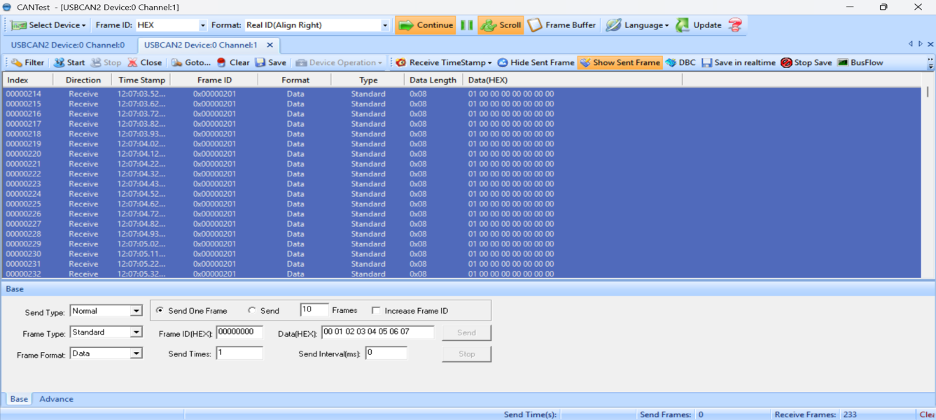
Figure 23 CAN Analyzer Normal Mode activation status

SPR Mode Verification (5 V to 20 V)
2. SPR Mode PD Contract Establishment
Title: USB PORT 1 SPR Mode PD Contract Establishment
Evidence Type: USB Power Delivery Tester Screenshot
Description:
Screenshot showing successful PD negotiation in SPR mode with contract type indicated as SPR. The sink send request for SPR mode to source then source accept the request to check communication between each other. The message about power supply ready (PS RDY) will display on communication log. This indicates USB PD negotiation in SPR mode. PD negotiation sequence in this capture mention below:
- Source Cap (Source Capabilities)
The Source shows available voltages such as: 5 V, 9 V, 15 V, 20 V (Fixed PDOs)
- GoodCRC
Sink sends GoodCRC to confirm the message was received correctly.
- Request
The Sink requests a specific voltage. Here it requests: Fixed 5V, 3A
- Accept
The Source accepts the Sink request.
- PS_RDY (Power Supply Ready)
The Source confirms it has switched to the requested output and is ready to supply power.
IBUS shows 0A because during PD negotiation no load is applied.
At the stage of Source Cap → Request → Accept → PS_RDY, the sink is only establishing the power contract and has not started drawing current yet.
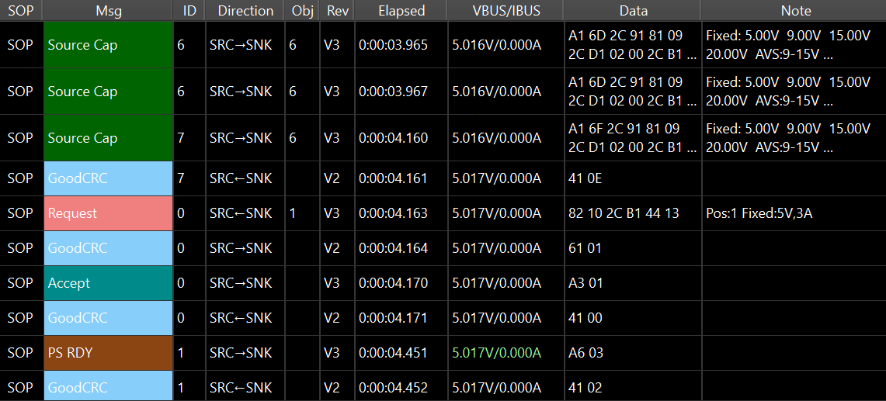
Figure 24 USB PD negotiation in SPR mode

3. USB Port 1 Output at 5 V (SPR)
Title: USB Port 1 Output – 5 V SPR Mode
Evidence Type: USB PD Tester Screenshot
Description:
Screenshot showing only negotiated voltage setting at 5 V in SPR mode with communication between sink and source.
1. Source Cap: The Source shows available voltages (5V/9V/15V/20V).
2. Request: The Sink selects and requests one voltage (here 5V, 3A).
3. Accept: The Source agrees to provide the requested voltage.
4. PS_RDY: The Source confirms it has switched to the requested output and is ready to supply power.
5. GoodCRC: Acknowledgement confirming each message was received correctly.
IBUS shows 0A because during PD negotiation no load is applied.
At the stage of Source Cap → Request → Accept → PS_RDY, the sink is only establishing the power contract and has not started drawing current yet.
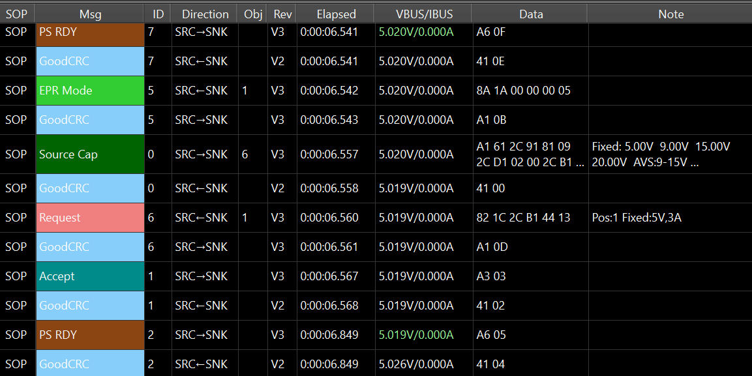
Figure 25 USB Port 1 output at 5 V in SPR mode
Description:
Screenshot showing VBUS output voltage at 5 V with stable IBUS 3 A current graph.

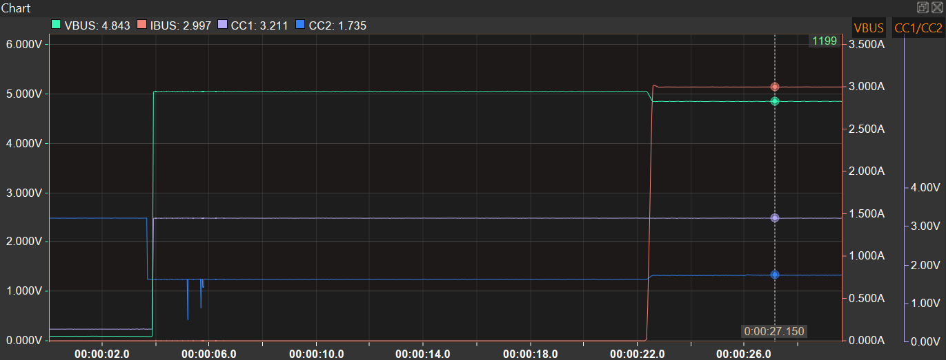
Figure 26 USB Port 1 VBUS output at 5 V/3 A
4. USB Port 1 Output at 9 V (SPR)
Title: USB Port 1 Output – 9V SPR Mode
Evidence Type: USB PD Tester Screenshot
Description:
Screenshot showing only negotiated voltage setting at 9 V in SPR mode with communication between sink and source.
1. Request: The Sink selects and requests one voltage (here 9V, 3A).
2. Accept: The Source agrees to provide the requested voltage.
3. PS_RDY: The Source confirms it has switched to the requested output and is ready to supply power.
4. GoodCRC: Acknowledgement confirming each message was received correctly.
IBUS shows 0A because during PD negotiation no load is applied.
At the stage of Source Cap → Request → Accept → PS_RDY, the sink is only establishing the power contract and has not started drawing current yet.

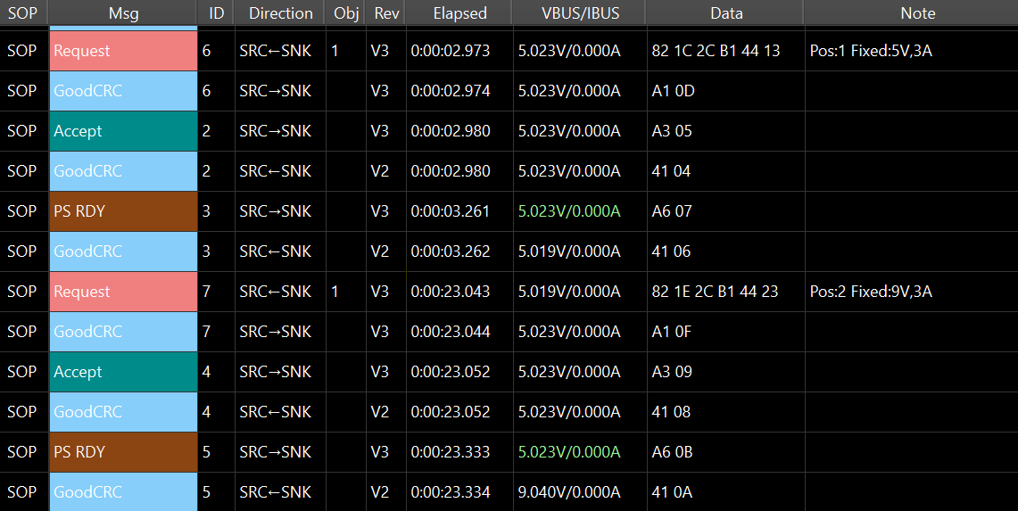
Figure 27 USB Port 1 output at 9 V in SPR mode
Description:
Screenshot showing VBUS output voltage at 9 V with stable IBUS 3 A current graph.

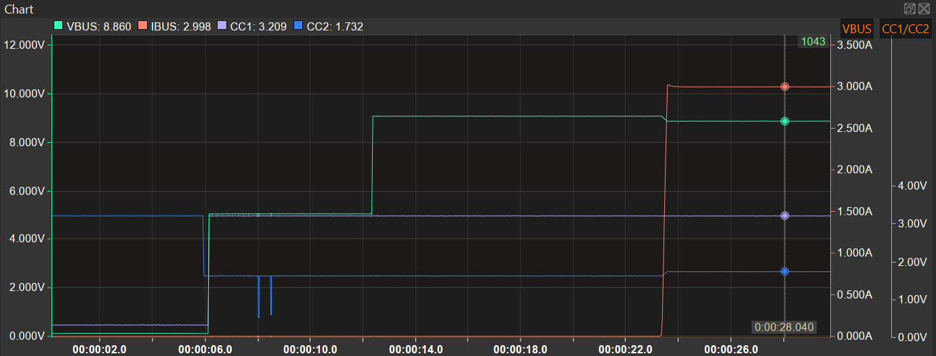
Figure 28 USB Port 1 VBUS output at 9 V/3 A

5. USB Port 1 Output at 15 V (SPR)
Title: USB Port 1 Output – 15 V SPR Mode
Evidence Type: USB PD Tester Screenshot
Description:
Screenshot showing only negotiated voltage setting at 15 V in SPR mode with communication between sink and source.
1. Request: The Sink selects and requests one voltage (here 15V, 3A).
2. Accept: The Source agrees to provide the requested voltage.
3. PS_RDY: The Source confirms it has switched to the requested output and is ready to supply power.
4. GoodCRC: Acknowledgement confirming each message was received correctly.
IBUS shows 0A because during PD negotiation no load is applied.
At the stage of Source Cap → Request → Accept → PS_RDY, the sink is only establishing the power contract and has not started drawing current yet.

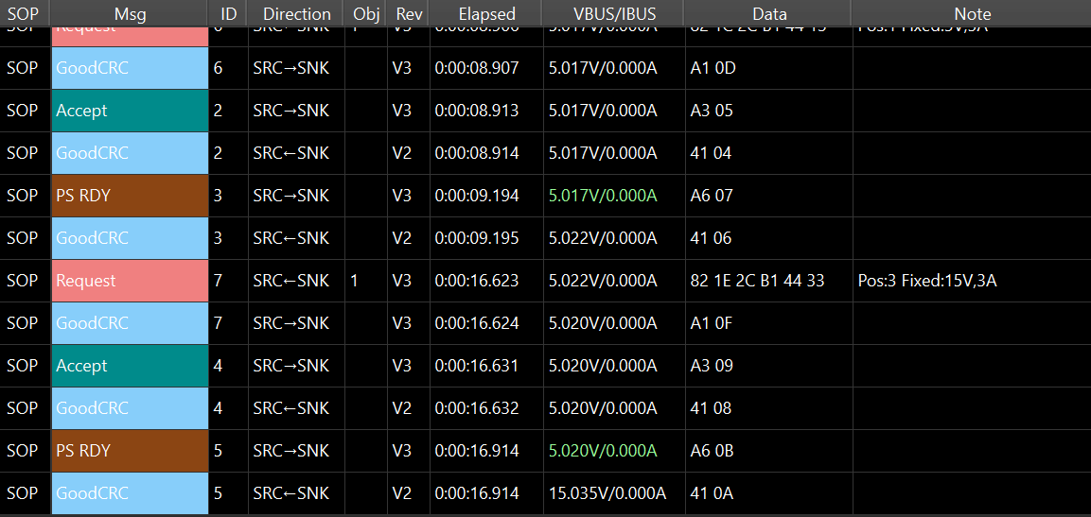
Figure 29 USB Port 1 output at 15 V in SPR mode
Description:
Screenshot showing VBUS output voltage at 15 V with stable IBUS 3 A current graph.

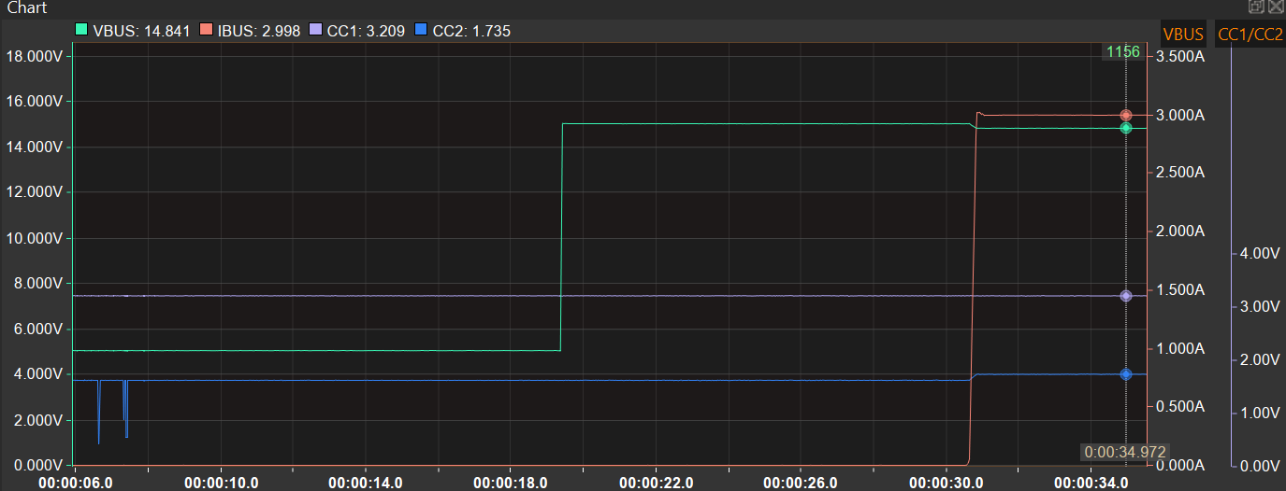
Figure 30 USB Port 1 VBUS output at 15 V/3 A

6. USB Port 1 Output at 20 V (SPR)
Title: USB Port 1 Output – 20 V SPR Mode
Evidence Type: USB PD Tester Screenshot
Description:
Screenshot showing only negotiated voltage setting at 20 V in SPR mode with communication between sink and source.
1. Request: The Sink selects and requests one voltage (here 20V, 5A).
2. Accept: The Source agrees to provide the requested voltage.
3. PS_RDY: The Source confirms it has switched to the requested output and is ready to supply power.
4. GoodCRC: Acknowledgement confirming each message was received correctly.
IBUS shows 0A because during PD negotiation no load is applied.
At the stage of Source Cap → Request → Accept → PS_RDY, the sink is only establishing the power contract and has not started drawing current yet.

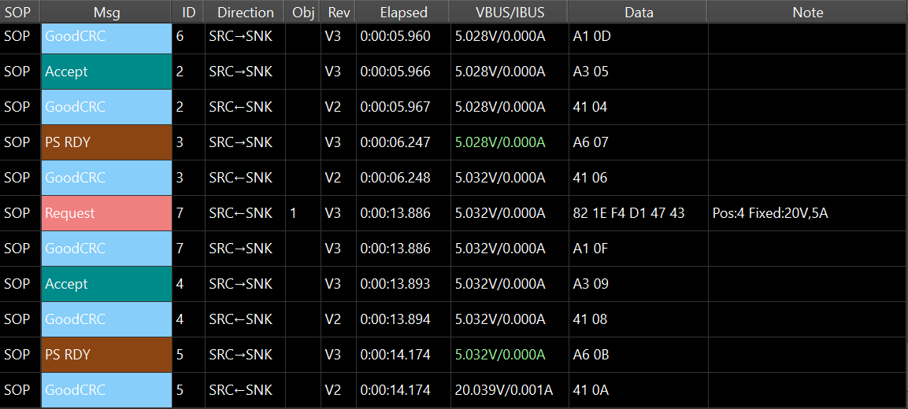
Figure 31 USB Port 1 output at 20 V in SPR mode
Description:
Screenshot showing VBUS output voltage at 20 V with stable IBUS 5 A current graph.

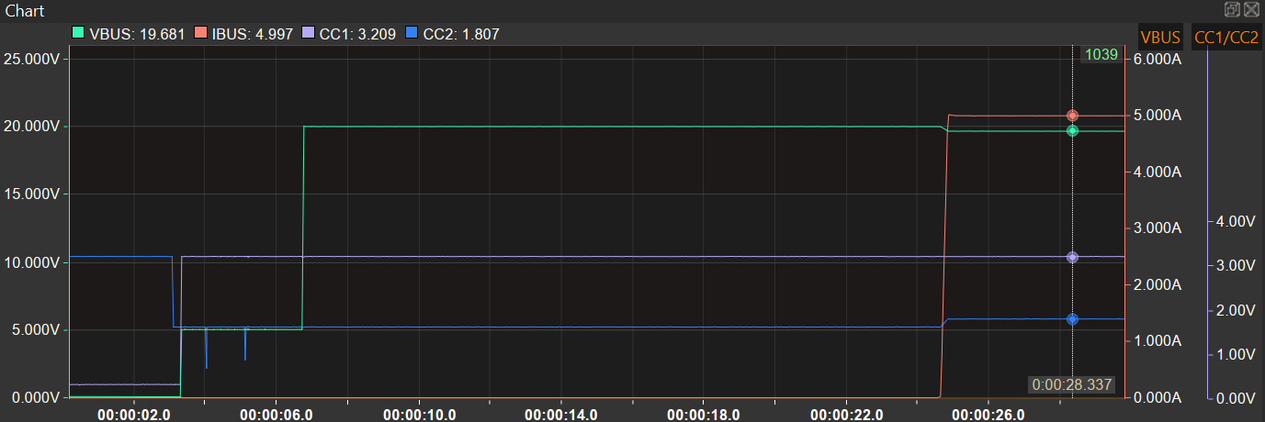
Figure 32 USB Port 1 VBUS output at 20 V/5 A
EPR Mode Verification (28 V to 48 V)
8. EPR Mode PD Contract Establishment
Title: USB Port 1 EPR Mode PD Contract Establishment
Evidence Type: USB Power Delivery Tester Screenshot
Description:
Screenshot confirming successful negotiation of an EPR PD contract. The sink send request for EPR to source then source accept the request to check communication between each other. The message about power supply ready (PS RDY) will display on communication log following which the Extended_Contro display for EPR mode is present. This indicates USB PD negotiation in EPR mode.
1. GoodCRC: Acknowledgement that the previous message was received correctly.
2. EPR_Source_Capabilities: Source shows EPR voltage (higher voltage/current capability).
3. EPR Request: Sink requests an EPR contract (higher voltage).
4. Accept: Source accepts the EPR request.
5. PS_RDY: Source confirms EPR output is ready and stable.
6. Extended_Control: Additional extended PD control message used in EPR communication.
The sink is in negotiation/transition stage, so the load is not enabled. Therefore, current draw is near zero and shown as 0.000A.
After PS_RDY, voltage jumps to around 48V, and a small current (0.001A) appears, indicating only standby/minimum load current.

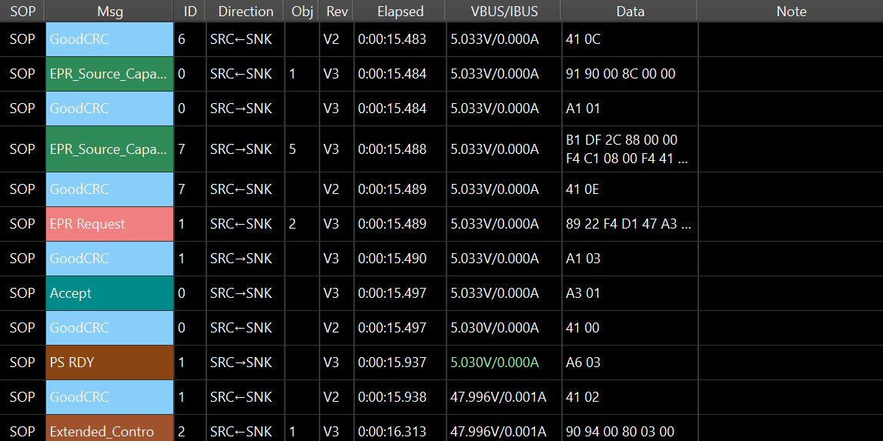
Figure 33 USB PD negotiation in EPR mode

9. USB Port 1 Output at 28 V (EPR)
Title: USB Port 1 Output – 28 V EPR Mode
Evidence Type: USB PD Tester Screenshot
Description:
Screenshot showing only negotiated voltage setting at 28 V in EPR mode with communication between sink and source.
1. GoodCRC: Acknowledgement confirming previous message was received correctly (e.g., GoodCRC ID 1, 2, 3).
2. Extended_Control: Represents an additional control message sent between the source and sink during the EPR negotiation (e.g., Extended_Contro ID 1, 2, 3).
During this negotiation phase, the voltage (VBUS) fluctuates between 27.621 V and 27.706 V, with current (IBUS) of about 3.966 A to 5.003 A.

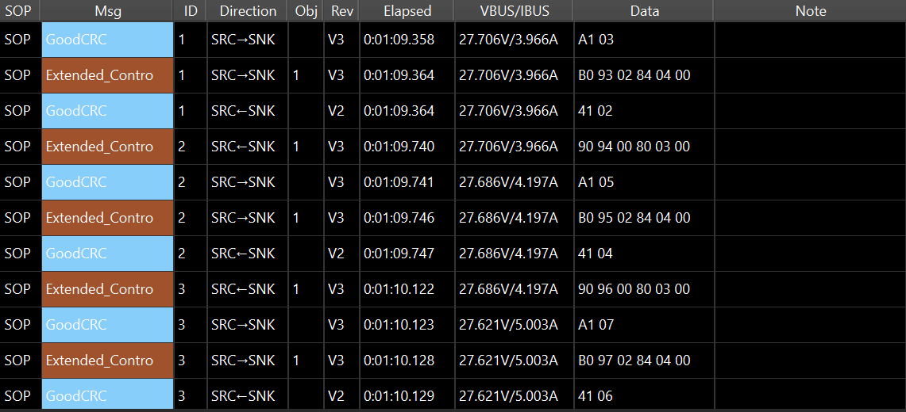
Figure 34 USB Port 1 output at 28 V in EPR mode
Description:
Screenshot showing VBUS output voltage at 28 V with stable IBUS 5 A current graph.
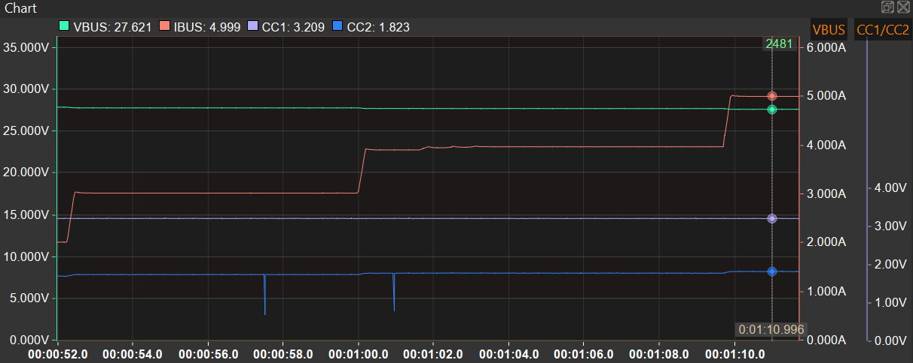
Figure 35 USB Port 1 VBUS output at 28 V/5 A

10. USB Port 1 Output at 36 V (EPR)
Title: USB Port 1 Output – 36 V EPR Mode
Evidence Type: USB PD Tester Screenshot
Description:
Screenshot showing only negotiated voltage setting at 36 V in EPR mode with communication between sink and source.
1. GoodCRC: Acknowledgement confirming previous message was received correctly (e.g., GoodCRC ID 7, 0, 1, 2).
2. Extended_Control: Represents an additional control message sent between the source and sink during the EPR negotiation (e.g., Extended_Contro ID 7, 0, 1, 2).
During this negotiation phase, the voltage (VBUS) fluctuates between 35.611 V and 35.609 V, with current (IBUS) of about 5.000 A to 5.001 A.

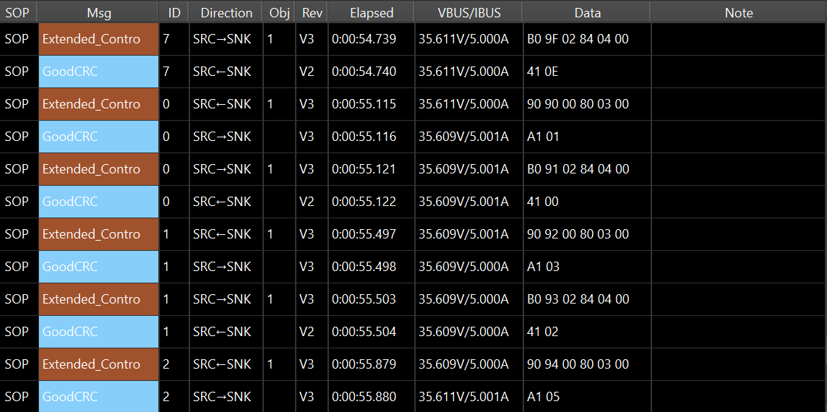
Figure 36 USB Port 1 output at 36 V in EPR mode
Description:
Screenshot showing VBUS output voltage at 36 V with stable IBUS 5 A current graph.
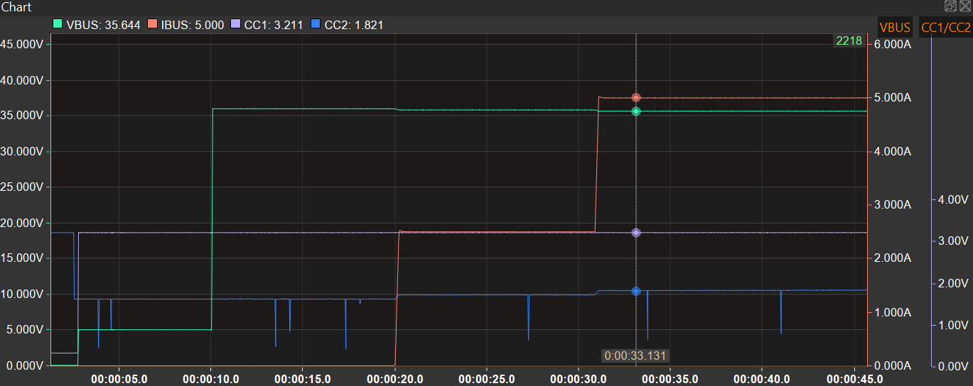
Figure 37 USB Port 1 VBUS output at 36 V/5 A
11. USB Port 1 Output at 48 V (EPR)
Title: USB Port 1 Output – 48 V EPR Mode
Evidence Type: USB PD Tester Screenshot
Description:
Screenshot showing only negotiated voltage setting at 48 V in EPR mode with communication between sink and source.
1. GoodCRC: Acknowledgement confirming previous message was received correctly (e.g., GoodCRC ID 0, 1, 2).
2. Extended_Control: Represents an additional control message sent between the source and sink during the EPR negotiation (e.g., Extended_Contro ID 0, 1, 2).
During this negotiation phase, the voltage (VBUS) fluctuates between 47.588 V and 47.585V, with current (IBUS) of about 5.002 A to 5.003 A.

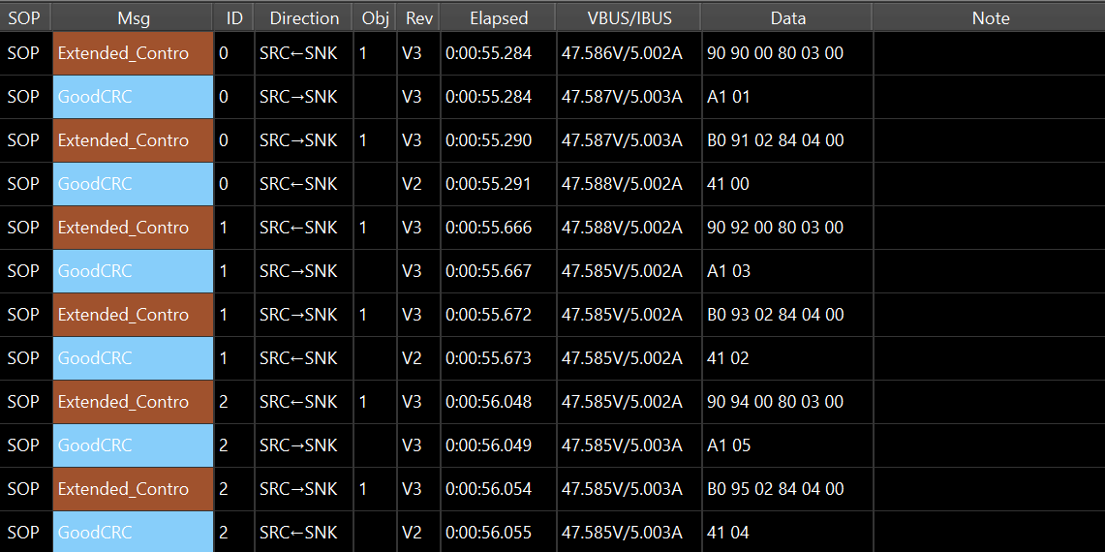
Figure 38 USB Port 1 output at 48 V in EPR mode
Description:
Screenshot showing VBUS output voltage at 48 V with stable IBUS 5 A current graph.
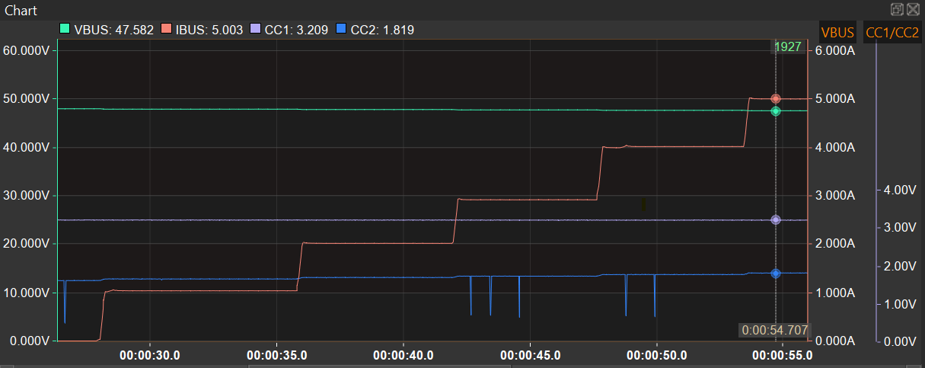
Figure 39 USB Port 1 VBUS output at 48 V/5 A

Conclusion
The operation of USB Port 1 was verified in Normal Mode for both SPR and EPR modes. The USB Port 1 successfully negotiated SPR voltages from 5 V to 20 V and EPR voltages from 28 V to 48 V using a USB Power Delivery tester. Stable output voltage and current were maintained at all tested voltage levels under load, with correct PD contract negotiation and no output interruption, renegotiation, shutdown, or fault indication observed. The test requirements are met, and the test result is PASS.

HVDC Filter PCB test
Test objective
The HVDC Filter PCB is intended to reduce EMI noise generated by the HV+ input so that the circuit functions properly. It helps prevent interference with other electronic components, protects sensitive circuits, and ensures stable performance without disturbances.

Test criteria
The HVDC Filter is tested by supplying HV+ input to ensure stable output voltage with minimal voltage drop across the filter components.

Expected Input Power | Expected Output Power | Expected Efficiency
1.50 kW | 1.38 kW | 92.11%
Table 25 Expected output for HV filter test
Note: The minimum system output power requirement is 1.32 kW as per total output ports, so we have tested the HVDC Filter for 1.50 kW. The HVDC Filter is carried forward from 1500W, so no specific criteria is available for judgement. Hence the 92.11% HV DCDC MATLAB efficiency for HVDC Filter is considered.

Test setup
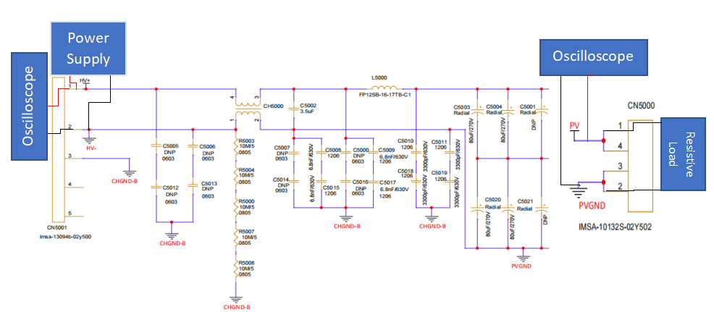
Figure 40 HV filter circuit
The HV+ input supply voltage at high range with ground connected to HV GND. Input decoupling capacitor connected across HV+ and HV– reduces high frequency noise, and ripple generated by switching circuits.

Test method
The test uses the high-voltage DC input (HV+ and HV–) from the power supply to the HVDC Filter circuit. Oscilloscopes are connected to both input and output sides of the circuit to observe results on each individual channel. The B2B connector is connected between the main PCB and the filter PCB, separate CHGND-B and PVGND reduce noise coupling.
Step 1: Power
- Apply input supply to HV+ pin 1(CN5001).
- Tie supply HV GND to board HV- signal (Power stage remains disconnected).

Step 2: Load setup
- Load setup at CN5000 output PV signal with one end attached PVGND (Power stage remains disconnected).
Step 3: Connect oscilloscope
- Connect the probe ground to the HV- CN5001(pin 2) and PVGND CN5000(2 and 3).
- Oscilloscope channel 1 to (HV+ and HV–) and channel 3 to (PV and PVGND).
Step 4: Power ON and observe
- Turn ON the HV+ input supply.
- Monitor the output PV signal on the oscilloscope.
- Verify that the output has minimal ripple and high accuracy.
Step 5: Shutdown
- Turn OFF HV+.

Test results
*The DSO used for measurement displays values has fixed 5-digit resolution. The last digit written as 0 in the table only to maintain a consistent three-decimal format and it does not represent an additional measurement; it only indicates that no further precision is available beyond the instrument resolution.
Note:
Light Blue → HVDC filter current signal
Yellow → HVDC filter input voltage signal
Pink → HVDC filter output voltage signal
Blue → HVDC filter output current signal
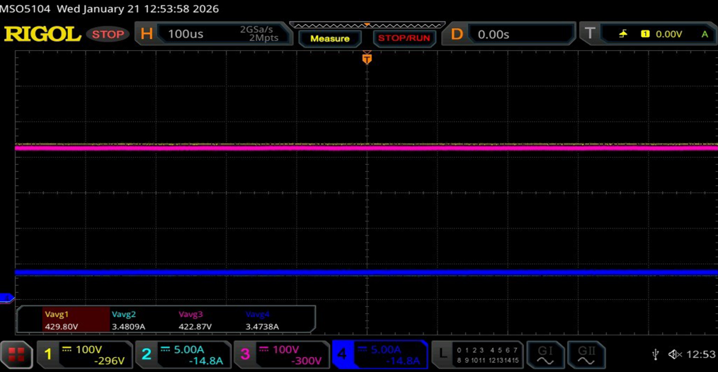
Figure 41 HVDC filter circuit
Parameter | Input Measured | Output Measured | Expected Efficiency (MATLAB simulation based) | Measured Efficiency | Judgement
Voltage | 429.80 V | 422.87 V | - | - | -
Current | 3.48 A | 3.47 A | - | - | -
Power | 1.50 kW | 1.47 kW | 92.11 % | 98.00 % | PASS
Table 26 HVDC Filter output voltage test result verification table

Conclusion
From the test results, the input power is 1.50 kW, and the output power is 1.47 kW, resulting in a measured efficiency of approximately 98.00 %. The output waveform remained stable with minimal ripple, confirming that the HVDC filter effectively reduces EMI noise while allowing efficient power transfer.

Abbreviations list
ACCUSB Accessory 3 port (12Volts 10 Amps) and
High Power USB PD 4 Port (each port max 240 watts) integrated power supply
USB PD stands for Universal Serial Bus Power Delivery Protocol
B2B Board to Board
CAN Controller Area Network
CN Connector
DC Direct Current
DSO Digital Storage Oscilloscope
EPR Extended Power Range
GND Ground
HDD Hardware Design Document
HSIS Hardware/Software Interface Specification
HV High Voltage
I2C Inter-Integrated Circuit
IC Integrated Circuit
LDO Low Dropout Regulator
MCU Microcontroller Unit
SPR Standard Power Range
TP Test Point

************************End of report *********************************

